**Experiment NO.7:( DQL COMMANDS (COLLEGE SCHEMA))**

**AIM:**

* Display student id and marks from the student table.
* Display faculty id and name from the faculty table.
* Display who got grade A.
* Display whose marks are less than 90.
* Display the students whose marks are between 80 to 90.
* Delete the failed students.
* Display activity id and name using object.
* Display student id, faculty id using course name condition with object.
* Select department name starting from ‘d’ and faculty name ending with ‘ ’.
* Select activity having characters between ‘ck’.
* Group by faculty id and display.
* Display the students list whose grade is A using having.
* Display the faculty list who are teaching DBMS.
* Apply aggregate functions in student marks - max, min, sum, count, avg.

**Solution:**

**Components:**

1. DQL statements are used for performing queries on the data within schema objects. The purpose of the DQL Command is to get some schema relation based on the query passed to it.

Example of DQL:

* + [SELECT](https://www.geeksforgeeks.org/sql-select-clause/) – is used to retrieve data from the database.

**CODE:**

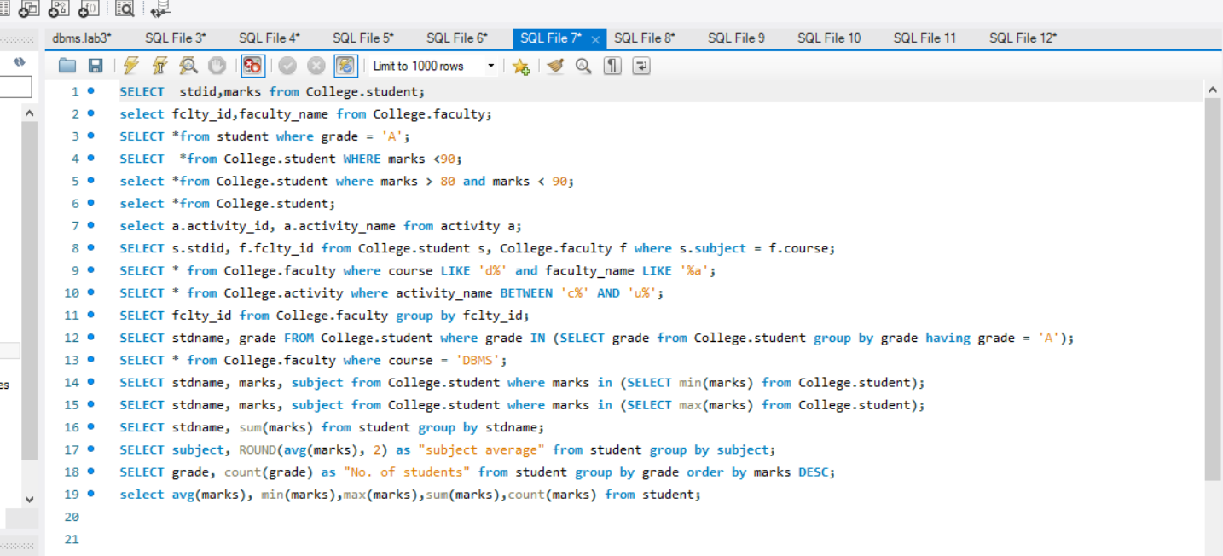

SELECT stdid,marks from College.student;

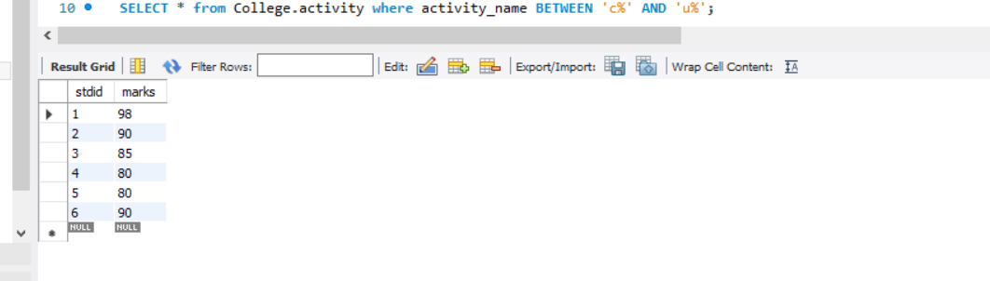

select fclty_id,faculty_name from College.faculty;

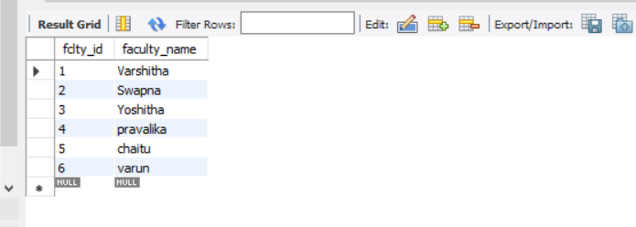

SELECT *from student where grade = 'A';

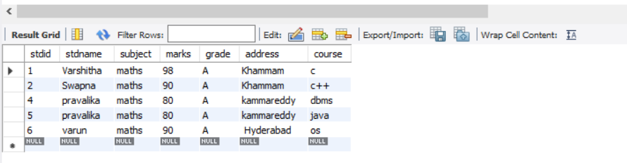

SELECT *from College.student WHERE marks <90;

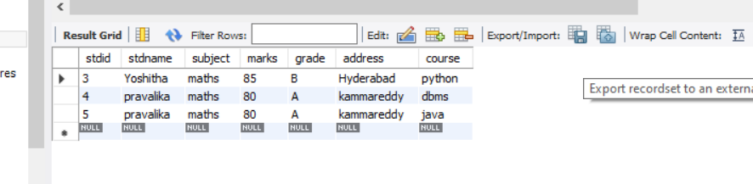

select *from College.student where marks > 80 and marks < 90;

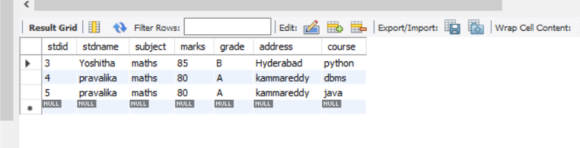

select * from student;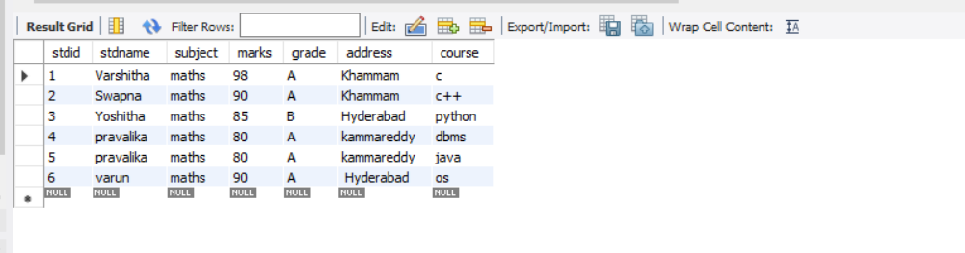

select a.activity_id from activity a;

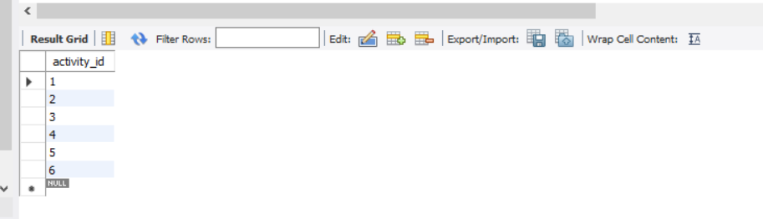

SELECT s.stdid, f.fclty_id from College.student s, College.faculty f where s.subject = f.course;

SELECT * from College.faculty where course LIKE 'd%' and faculty_name LIKE '%a';

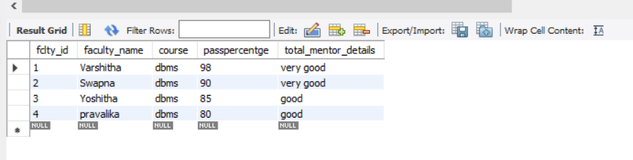

SELECT * from College.activity where activity_name BETWEEN 'c%' AND 'u%';

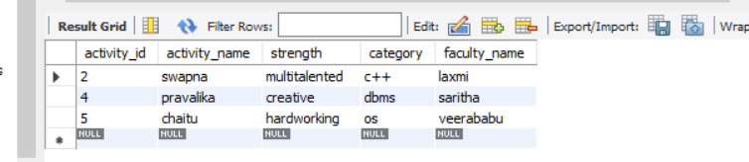

SELECT fclty_id from College.faculty group by fclty_id;

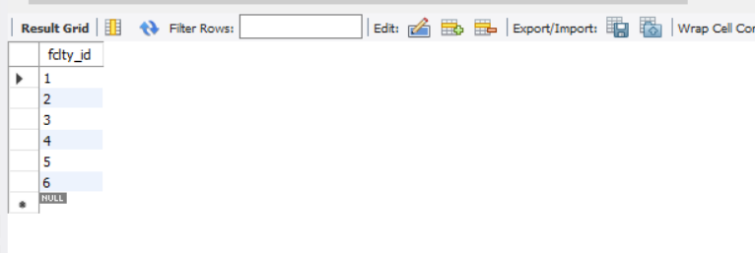

SELECT stdname, grade FROM College.student where grade IN (SELECT grade from College.student group by grade having grade = 'A');

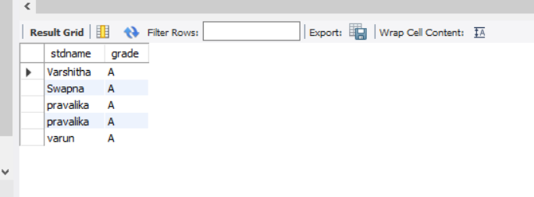

SELECT * from College.faculty where course = 'DBMS';

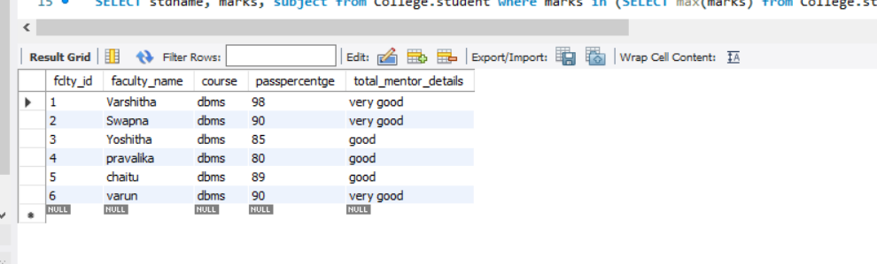

SELECT stdname, marks, subject from College.student where marks in (SELECT min(marks) from College.student);

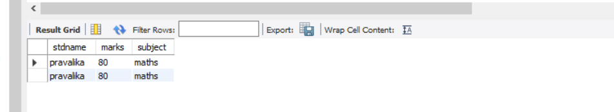

SELECT stdname, marks, subject from College.student where marks in (SELECT max(marks) from College.student);

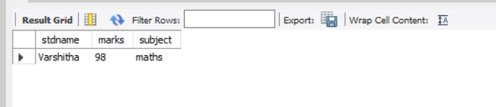

SELECT stdname, sum(marks) from student group by stdname;

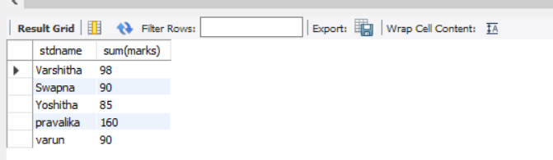

SELECT subject, ROUND(avg(marks), 2) as "subject average" from student group by subject;

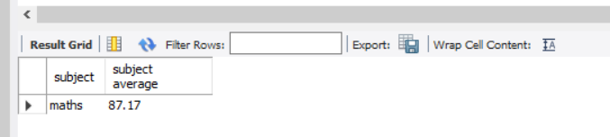

SELECT grade, count(grade) as "No. of students" from student group by grade order by marks DESC;

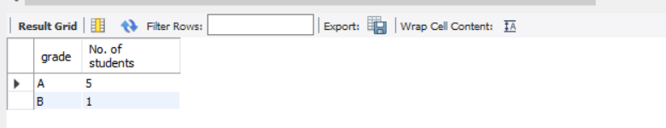

select avg(marks), min(marks),max(marks),sum(marks),count(marks) from student;

